June 26 client comfort letter (general)
June 26, 2020
[Date]
Dear Client,
I hope all is well. Below you will find a summary of this week’s market developments and subsequent thoughts.
Market developments
- North American equity markets proved volatile this week, reacting to increasing numbers of COVID-19 infections in 27 states and fears of new lockdowns and decreased economic activity. In particular, cases continued to soar in Florida, Texas, Arizona and California.
- The International Monetary Fund (IMF) now expects global economic output to contract 4.9% in 2020, with U.S. output contracting 8.0% and Canadian output 8.4%.
- Ratings agency Fitch Ratings downgraded Canada's credit rating to 'AA+' from 'AAA' to reflect the deterioration of public finances due to COVID-19.
- New Bank of Canada Governor Tiff Macklem said that Canada’s economy will take a long time to fully recover from lockdowns, requiring the central bank to continue purchasing government bonds to keep interest rates low indefinitely.
- President Donald Trump said that a second stimulus bill was coming and would likely be announced in the next few weeks. Weekly jobless claims in the U.S. were 1.48 million, and real gross domestic product (GDP) contracted at an annual rate of 5.0% in the first quarter of 2020.
How does this affect my investments?
A resurgence of COVID-19 cases across the United States has caused investors to consider the implications of a second series of lockdowns, something many hoped would be unnecessary moving forward. As economic forecasts continue to show the damage caused by the pandemic, it is understandable that sentiment may turn bearish in the short term.
With that said, our decision to stick with our long-term plan even when markets hit their lows in March ultimately proved prudent, and my advice is to continue to do so, even when sentiment appears to change. The chart below serves to illustrate this point, demonstrating that often times when investors turn increasingly bearish, markets may be poised to move the other way.

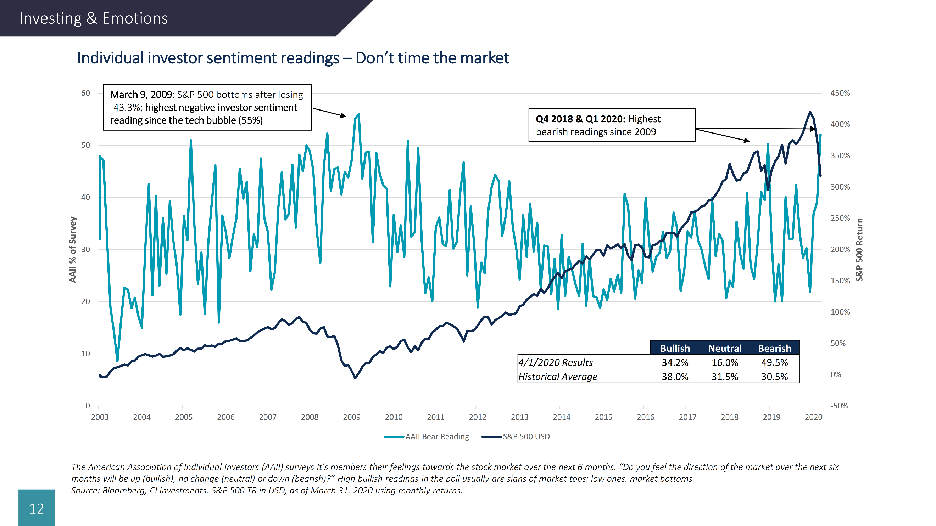

Source: Bloomberg Finance L.P., CI Investments. S&P 500 TR in USD, as of March 31, 2020 using monthly returns.

I am always happy to discuss your investment plans. Please do not hesitate to contact me at (xxx) xxx-xxxx.

Sincerely,

Financial Advisor Name

Sources: CI Investments Inc., marketwatch.com, fxstreet.com, theglobeandmail.com, fitchratings.com, bostonglobe.com, and forbes.com.

