[Date]
Dear Client,
I trust that all is well with you and your family this week. Below you will find a summary of this week’s market developments and some further thoughts.
Market developments
- North American markets again moved higher on continued optimism over re-openings; all 50 U.S. states have now at least partially re-opened their economies.
- White House health advisor Dr. Anthony Fauci stated that a second wave of coronavirus is “not inevitable” if states re-open correctly, and said there’s a “good chance” a vaccine could be deployed by year’s end. As of May 27, new cases in the U.S. rose at a rate of 1.2%, down from 1.4% in the week prior.
- The European Union is said to be preparing a fiscal package worth more than $800 billion, and Japan is planning new economic stimulus valued in excess of $1 trillion.
- Weekly jobless claims in the U.S. were 2.1 million, passing 40 million in 10 weeks. Real gross domestic product (GDP) contracted at 5% in the first quarter.
- Tensions between the U.S. and China escalated as the House of Representatives passed legislation calling for sanctions against Chinese officials.
How does this affect my investments?
In previous letters, we have discussed the importance of sticking to your long-term plan, despite current market conditions. The incredible recovery we have seen since the recent market lows have included some very large gains on certain days, which have caught investors by surprise. By sticking to our plan, we look to avoid the risk of missing out on such days. Conversely, the chart below demonstrates what can happen to those who do try to time market moves.

Growth of $10K invested January 1, 1980
S&P 500 Index Fund (end date: January 1, 2019).
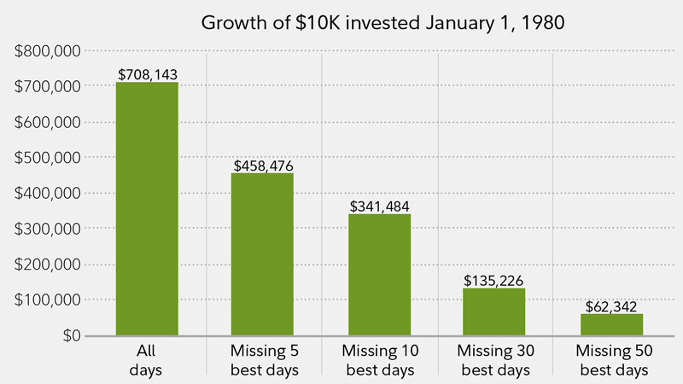

Source: thesimpledollar.com

This is not to say that this recent run will continue, nor that anyone is sure how North America’s return to normal will progress. It means that we are taking the approach that we believe will ultimately best align with your long-term goals.
As always, I am happy to discuss your investment plans. Please do not hesitate to contact me at (xxx) xxx-xxxx.

Sincerely,

Financial Advisor Name

Sources: CI Investments Inc., Bloomberg Canada, cnbc.com.

